1. Views

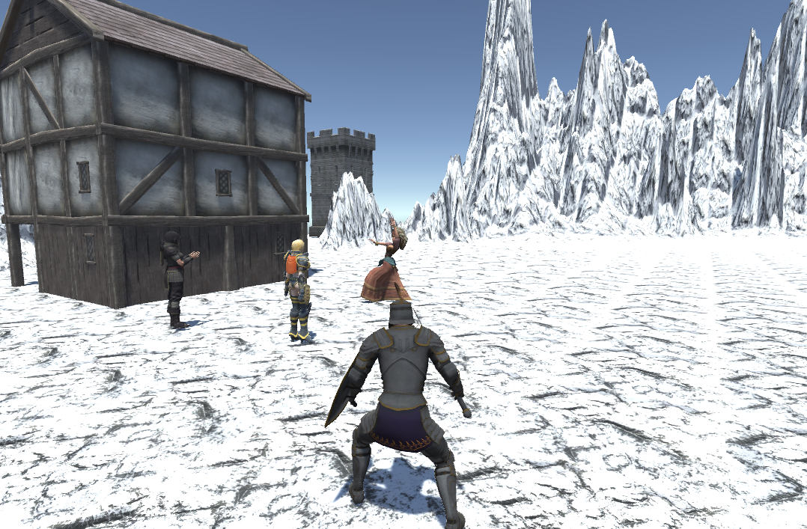

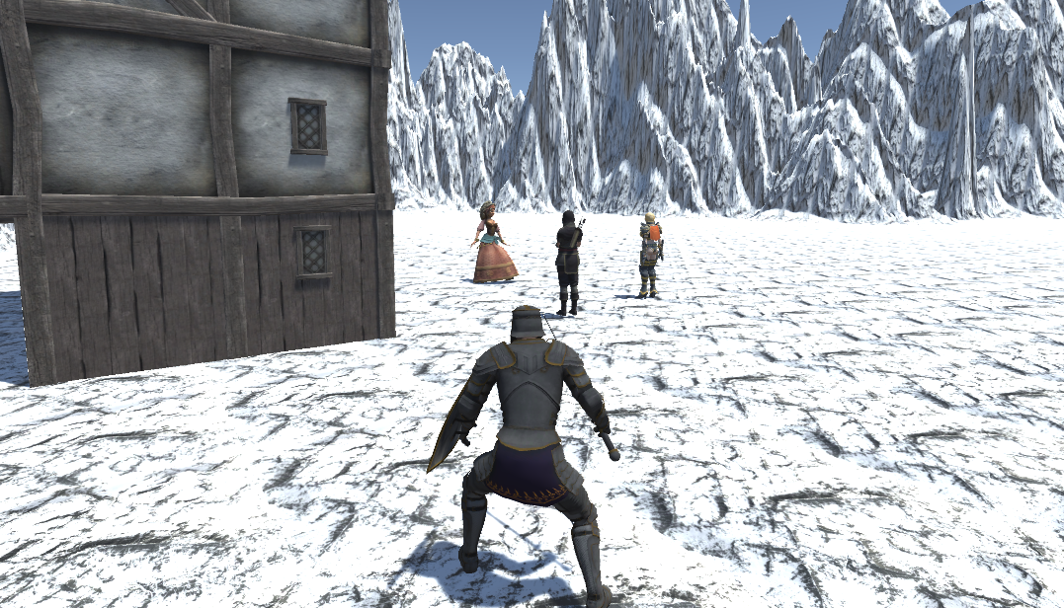

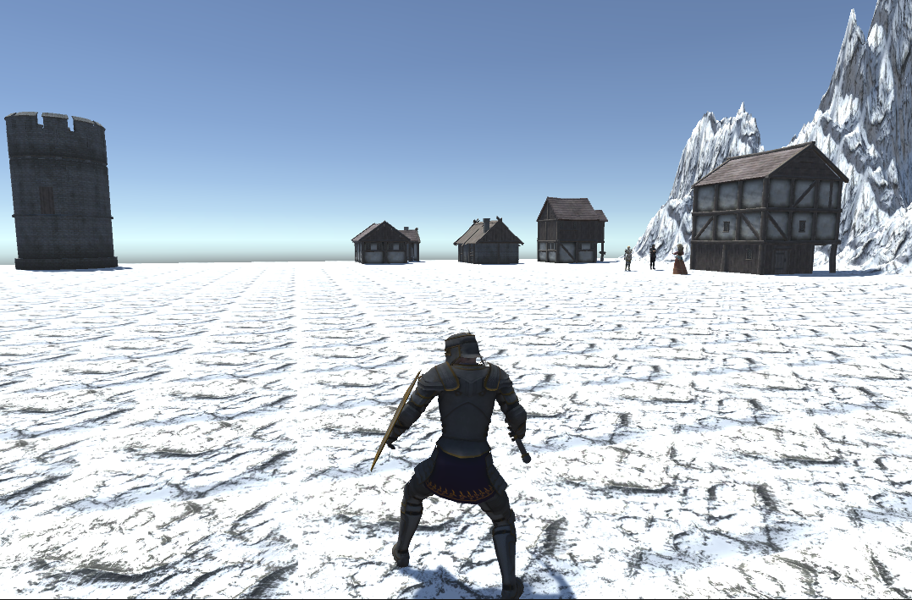

2. Moves

While running:

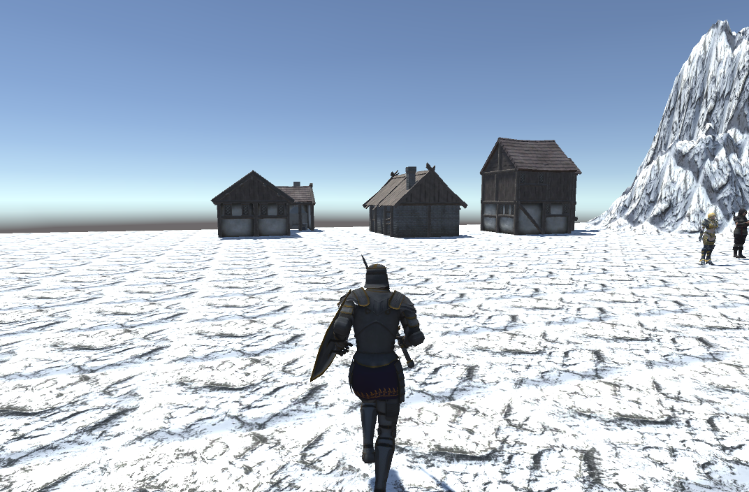

While walking:

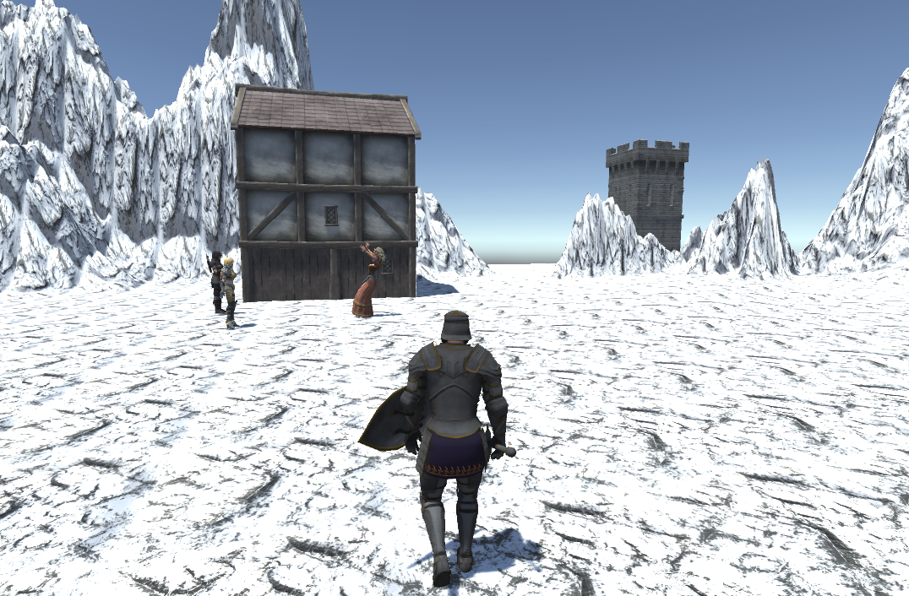

While sitting:

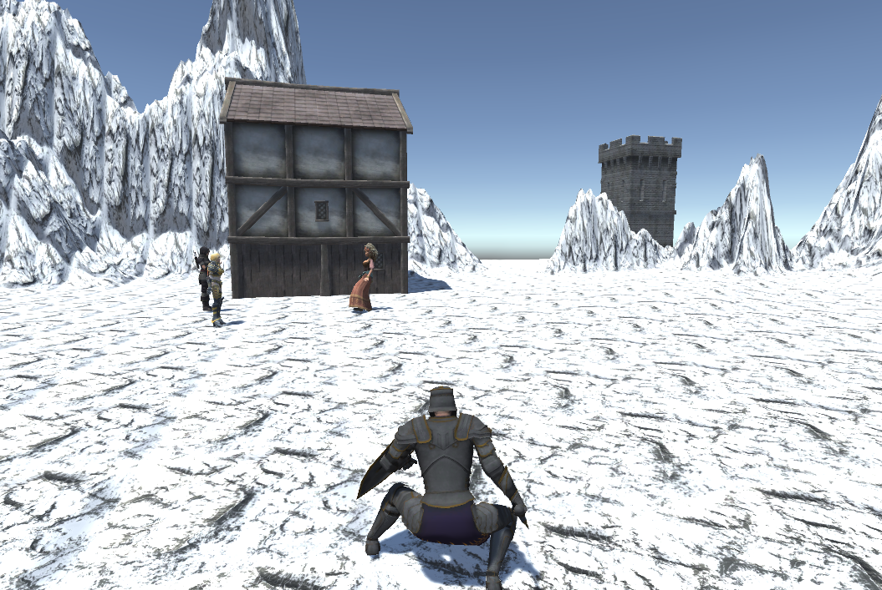

While crouching:

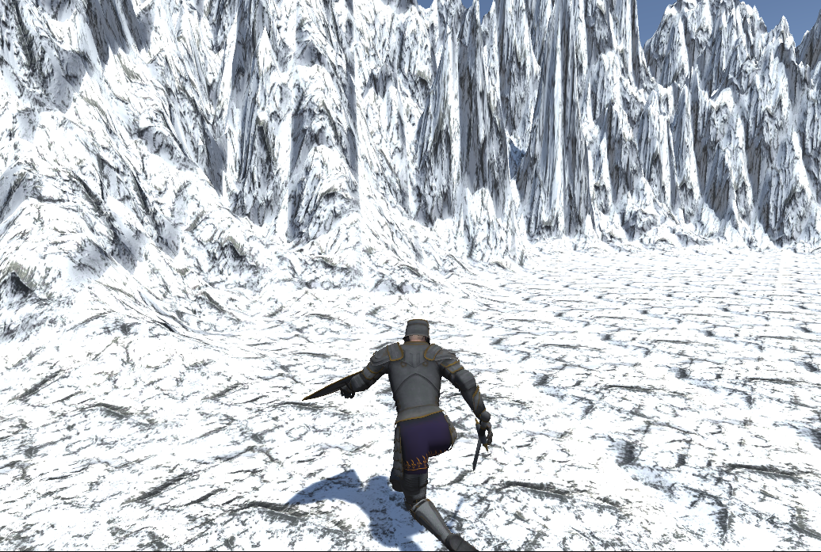

While laying:

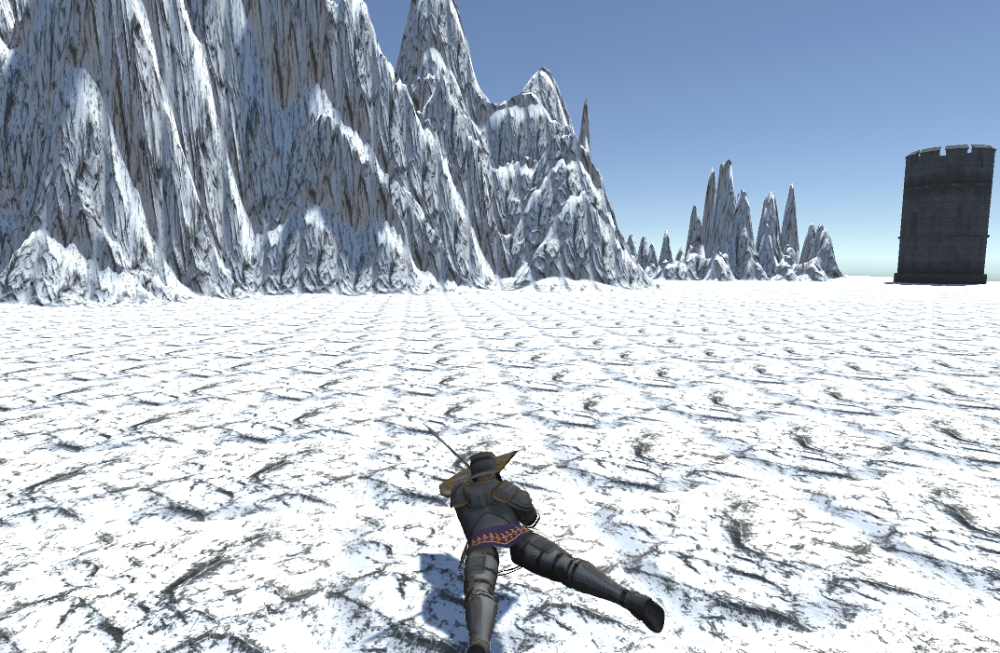

Moving while laying:

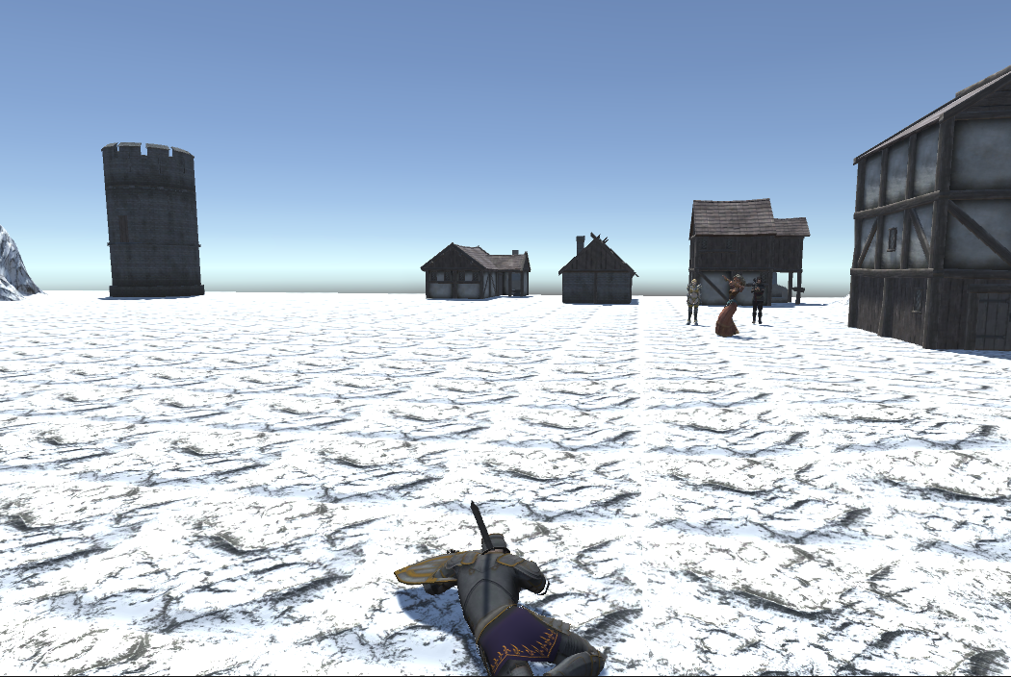

3. animation scheme

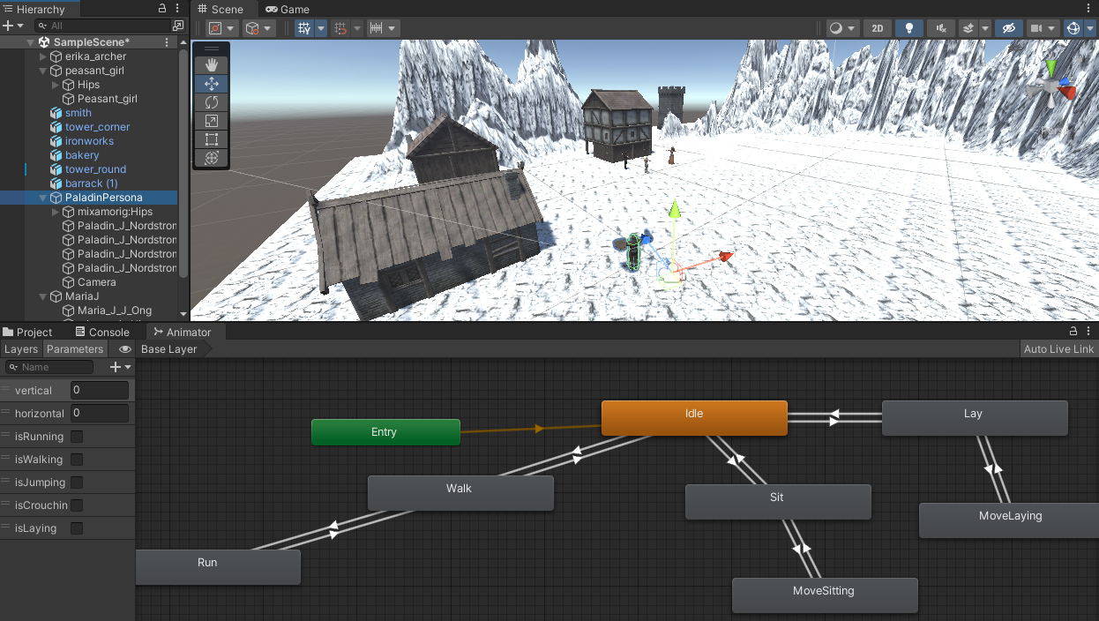

4 Code:

public class PaladinControlScript : MonoBehaviour

{

CharacterController character;

Animator animator;

[SerializeField] float speed_rotation = 1;

[SerializeField] float speed = 1;

// Start is called before the first frame update

void Start()

{

character = GetComponent<CharacterController>();

animator = GetComponent<Animator>();

}

// Update is called once per frame

void Update()

{

float horizontal = Input.GetAxis("Horizontal");

float vertical = Input.GetAxis("Vertical");

// walk (W)

if (Input.GetKeyDown(KeyCode.W))

{

animator.SetBool("isWalking", true);

}

if (Input.GetKeyUp(KeyCode.W))

{

animator.SetBool("isWalking", false);

}

// run (W + Shift)

if (Input.GetKeyDown(KeyCode.LeftShift))

{

animator.SetBool("isRunning", true);

speed = 5;

}

if (Input.GetKeyUp(KeyCode.LeftShift))

{

animator.SetBool("isRunning", false);

speed = 1;

}

// crouch

if (Input.GetKeyDown(KeyCode.LeftControl))

{

animator.SetBool("isCrouching", true);

}

if (Input.GetKeyUp(KeyCode.LeftControl))

{

animator.SetBool("isCrouching", false);

}

// lay

if (Input.GetKeyDown(KeyCode.CapsLock))

{

animator.SetBool("isLaying", true);

}

if (Input.GetKeyUp(KeyCode.CapsLock))

{

animator.SetBool("isLaying", false);

}

// turn body

transform.Rotate(0, horizontal * speed_rotation, 0);

Vector3 forward = transform.TransformDirection(Vector3.forward);

float total_speed = speed * Input.GetAxis("Vertical");

character.SimpleMove(forward * total_speed);

animator.SetFloat("vertical", vertical);

animator.SetFloat("horizontal", horizontal);

}

}